Academy Transformation Trust Further Education –
Social Distancing and Site Learner Capacity Plan
Considering social distancing guidelines along with the suitability and size of each space within our sites we have developed a ratio to safely accommodate learners whilst still meeting PHE Social distancing guidelines. The following is an example of the number of pupils that can be accommodate in a standard teaching space along with a tutor:
- 55M2 Classroom – 12 learners
The ratio adapts dependant on size and suitability of each space as not all of our sites are built to the standard BB103 space regulation. This has been developed using our capacity data, measured plans and knowledge of each site.
We have worked with an architect to draw up plans which outline the maximum safe spacing as detailed above:
55M2 classroom examples meeting social distancing requirements
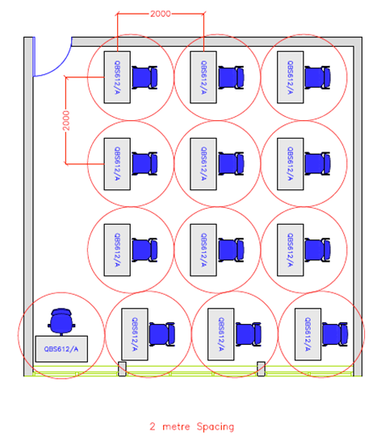

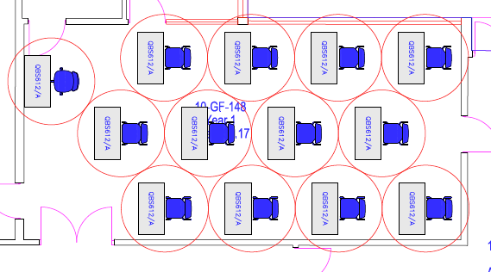
135M2 classroom examples meeting social distancing requirements
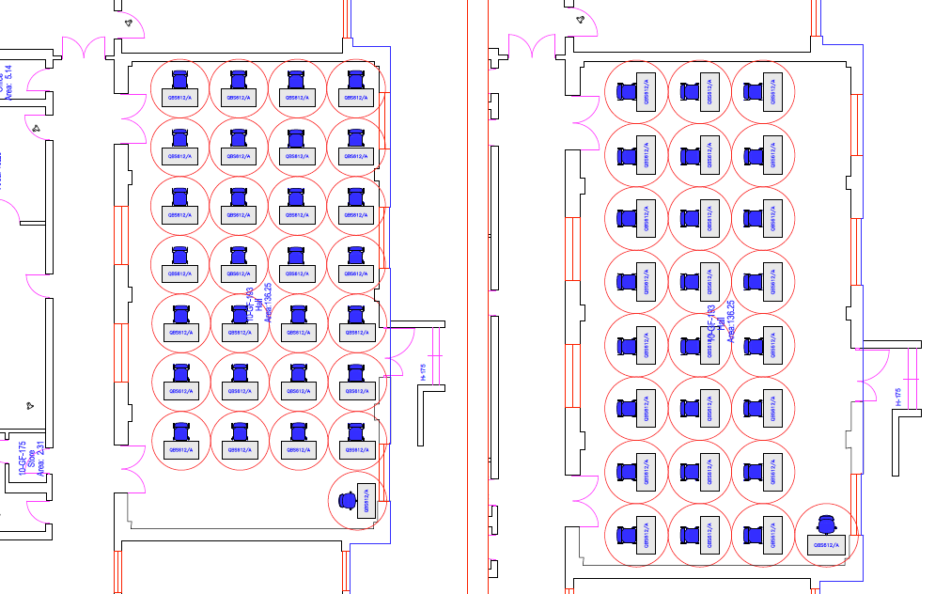

We have then taken this a process a step further and reviewed the available space at our sites. This is based on:
- The size of each space within building
- The suitability of each space taking into account fixed furniture and required tutor’s space
- Location of toilet facillities
- Size of corridor/circulation areas
- Number of learners expected in each group
- Specific needs of individual learners
This methodology has identified the number of learners that can be safely occupy each space within each ATTFE site and still meet social distancing requirements.
Wherever possible the air conditioning will be switched off to prevent airborne virus spreading. ‘Blower heaters’ will not be used for the same reason. Wherever practical and feasible, windows will be opened to provide ventilation.

Document Ownership: Simon Martin

Version No | Date of update | Updated by | Update Agreed by
1.3 | 10/12/2020 | T Binks | SMn

