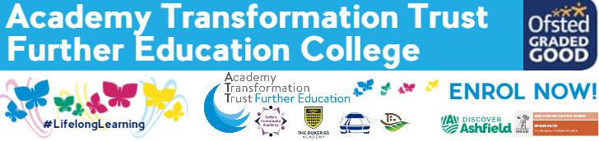

Level 2
Pathway

Transition Work Booklet

This transition pack is designed to help you make the change from year 11 to college, introducing a new way of working and to help you make the most of the opportunities which you will be given.

Here are some tasks to complete over the holiday ready for an assessment in September. The pack will also help you to look at the skills which you will need for a working environment. You do need to work your way through the transition tasks in the pack over the summer and hand in to your tutor when you start in September.

You will use this written work as evidence in your portfolio. We will show you how to reference this work at the beginning of the term. The work is set to help you to understand the importance of Equality and Diversity and how to behave in a manner that enables children to develop as confident, self-assured individuals. This unit of work underpins everything we do in our work settings and will help you to develop inclusive practice.

NB: All this work will be used as part of your course work so please give it the time and effort deserving of the qualification. This work will also help us determine if you show the academic ability required to complete the course to the standard set by the awarding body

Why the level 2 pathway?

The Level 2 Pathway aims to equip individuals with GCSEs, or GCSE-equivalent subjects at grade 4 or above. The course is perfect for students who would like to remain at ATTFE but do not meet the entry requirements to study higher level subjects.
You will have a four-day timetable at college, as well as spending one day a week at a work experience placement, this will complement your main aim studies at level 1 and enable you to develop valuable soft skills which will benefit you in your future career. This gives you the opportunity to develop working relationships with the same group of students, working at a similar level. You will be able to support each other in your studies and hopefully make some life-long friends.
Subjects

English GCSE
- Mathematics GCSE
- Level 1/2in your chosen subject area (Health & Social Care, Childcare, Beauty, Construction, Motor Vehicle)
Preparation for Work
This course will prepare you for life beyond college, supporting you in many aspects of your career, from constructing your CV, writing letters of application and interview techniques. You will also study responsibilities in the workplace, money management and relationships, both formal and informal.

English Task 1
The college website has asked for contributions for their creative writing page.
Either: Write a description suggested by this picture or write a story that begins with the sentence: ‘I was alone on the calm lake. There was nothing and no one in sight. Then I saw a ripple in the water.’

Financial Education: Task 2

Find out what the following abbreviations stand for and write a sentence to explain what they mean:
• P60  • H.M.R.C.  • D.W. P  • C.R.A.  • G.D.P | • P.A.Y.E.  • V.A.T.  • N.I.C.  • A.P.R.  • A.E.R.

Mathematics: Task 3
Solve the mathematical problems shown below on a separate sheet of paper, showing your working out wherever suitable.

Section A: Numbers & calculating | Section B: Algebra
1. To increase an amount by 7%, what single multiplier would you use? | 10. Expand & simplify: (x + 2)(x + 3)
2. To decrease an amount by 7%, what single multiplier would you use? | 11. Expand & simplify: (x + 2)(x – 3)
3. Increase £28 by 7% | 12. Solve: x + 1 < 5
4. Without a calculator work out: 0.2 x 0.3 | 13. Make n the subject of the formula:  M=3n
5. Without a calculator work out: 5 ÷ 0.1 | 14. Work out the value of: 3x + 2y When x = 5 and y = -4
6. Round off 17.2 to one significant figure | 15. Write down the next term in this sequence:  1 4 9 16 25
7. Estimate the answer to: 17 x 193 | 16. Write down the 1st term in the sequence given by:  T(n) = n² + 3
8. Use a calculator to work out: (1dp) (0.3 x 2.8)² | 17. If y = 3x² + 4 ,  find the value of y when x = 2
9. Use a calculator to work out: (1dp) 6.38 + 4.52  4.71 + 9.53 | 28. If y = x³ + 3 ,  find the value of y when x = 2

Preparation for Working Life: Task 3

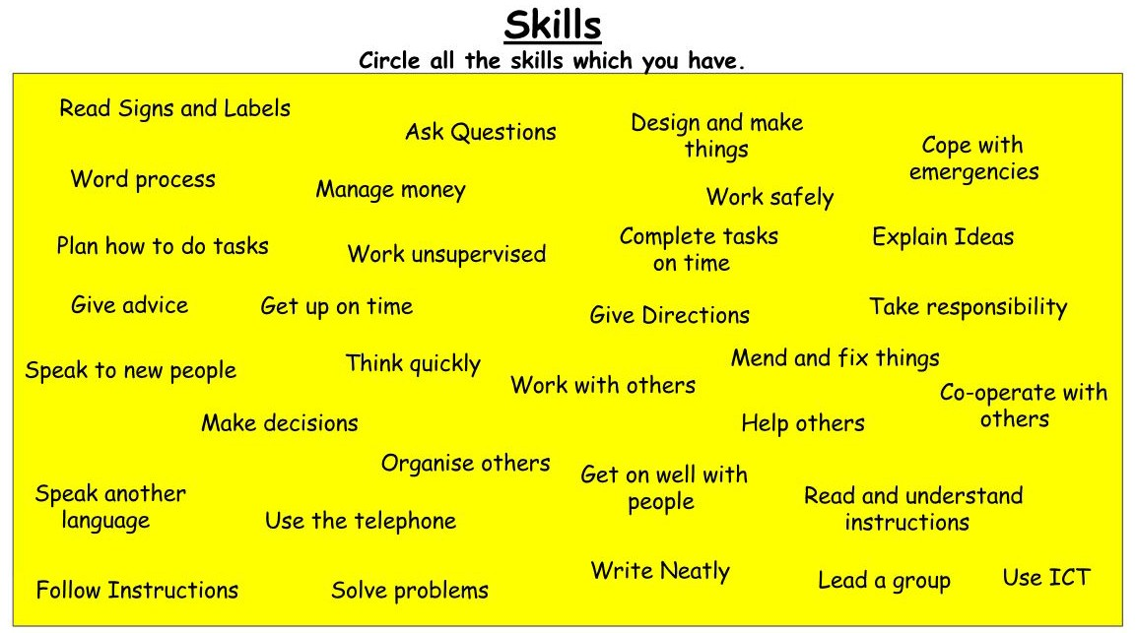
Place your skills into each circle and try to give an example of when you have

Complete the table below and include a reason why the skills you have chosen are important

Skill | Reason

