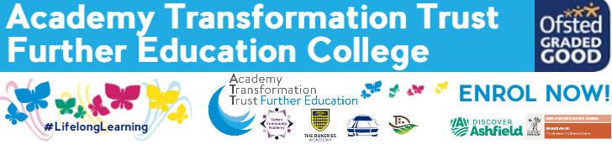

Health & Social Care:
SUMMER TRANSITION BOOKLET

What is Health and Social Care?

Health services are those in society which are designed to meet the health needs of the population. This includes hospitals, health centres, mental health support and involves the work of professionals such as doctors, nurses, midwives and healthcare assistants.
Social care services also provide support and care for individuals with additional needs. From care homes to social workers, all aspects of social care provide support for people going through difficult times in their lives when they have specific care needs which must be met.
Part of health and social care services also includes services for those in their early years. These early years services, such as nurseries or pediatric nurses, work with small children to ensure that their developmental needs are met.
All qualifications in health and social care are designed to prepare students with the knowledge and skills necessary to work in challenging job roles in both health services and the social care sector.
Health and social care could prepare you for a higher level qualification in FE or further training at university to pursue a career in professions such as social work, nursing or midwifery; or it could be used as preparation for applications to work as a health care or support assistant in a number of different care settings.

When you begin the course in September you will spend 3 days in college and 2 days in your work placement each week. The work placements are arranged, after discussion with each learner and course staff. Your work placement is a mandatory part of your course and commitment and attendance to placement is very important as without it you cannot remain on the course or complete the qualification.

This transition pack is designed to help you make the change from year 11 to college, introducing a new way of working and to help you make the most of the opportunities which you will be given.

Here are some tasks to complete over the holiday ready for an assessment in September. The pack will also help you to look at the skills which you will need for a working environment. You do need to work your way through the transition tasks in the pack over the summer and hand in to your tutor when you start in September.

You will use this written work as evidence in your portfolio. We will show you how to reference this work at the beginning of the term. The work is set to help you to understand the importance of Equality and Diversity and how to behave in a manner that enables children to develop as confident, self-assured individuals. This unit of work underpins everything we do in our work settings and will help you to develop inclusive practice.

NB: All this work will be used as part of your course work so please give it the time and effort deserving of the qualification. This work will also help us determine if you show the academic ability required to complete the course to the standard set by the awarding body

NCFE CACHE Level 1 Diploma in Introduction to Health, Social Care and Children’s and Young People’s Settings:
If you choose to study Health and Social Care, you will be studying the following units:

- MU 1.1: Understand the range of service provision and roles within health and social care
- MU 1.2: Understand the principles and values in health and social care
- MU 1.4: Awareness of protection and safeguarding in health and social
- MU 1.6: Introduction to communication in health and social care
- PWCS 03: Introductory awareness of equality and inclusion
- PWCS 04: Introductory awareness of health and safety
- PWCS 05: Introductory awareness of person-centered support
- PWCS 06: Introductory awareness of working with
- CFC 15: Human growth and development
- CT 260: Introduction to disability awareness
- MU 1.7: Introduction to children and young people’s development

Transition Tasks:

TASK 1
We use the concepts of health and wellbeing every day when discussing our lives and experiences. However, what do these terms actually mean in practice? Carry out some internet research to explain:
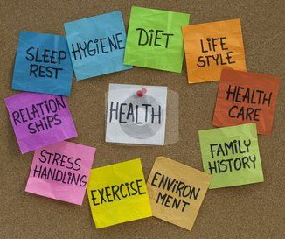
- What is health?
- What is ill health?
- What is wellbeing?

TASK 2
A wide range of factors can have a positive and negative impact on our health and wellbeing throughout our lives. Through a written report, poster or diagram:
EXPLAIN how your health and wellbeing (or the health and wellbeing of your favourite celebrity) has been influenced by different factors in your life.
You may want to consider factors such as genetics, friends, family, childhood experiences, income, environment, education and lifestyle as these will all impact on health and wellbeing, either positively or negatively.

TASK 3
What are your own health and social care career aspirations?
Explain them below and outline what you think you still need to so that you can go on to achieve them…

