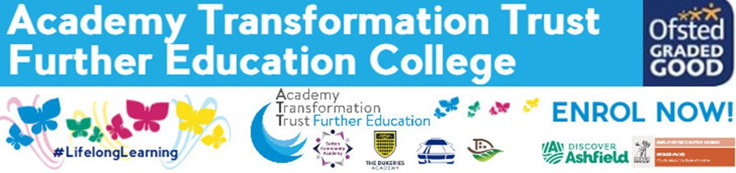
Hair, Beauty & Make-up:
SUMMER TRANSITION BOOKLET
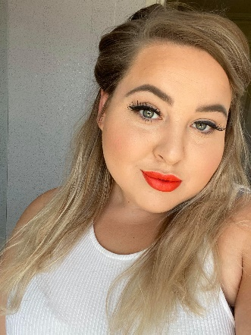
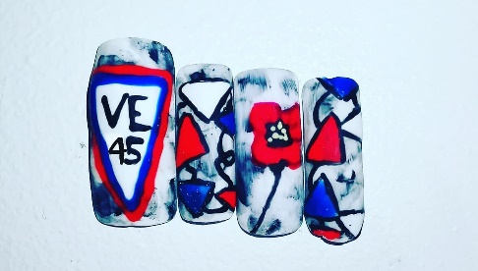
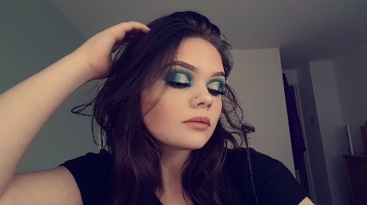
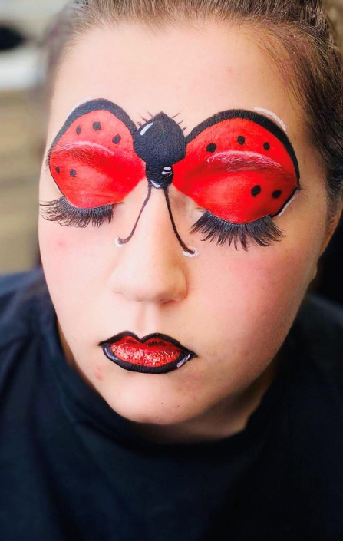
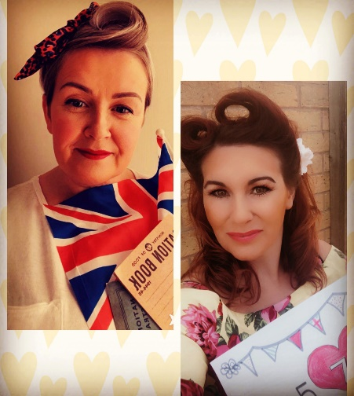
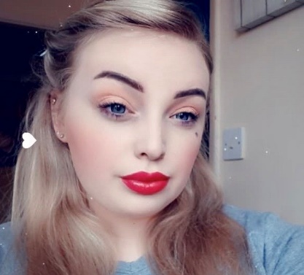

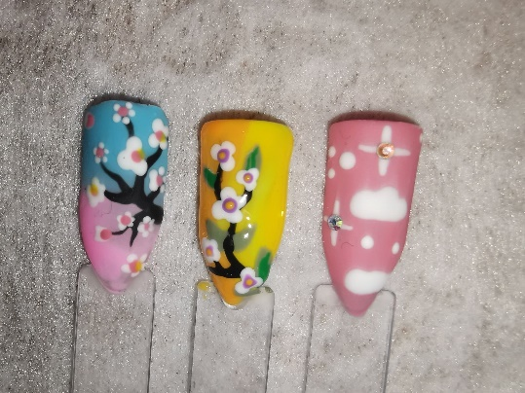

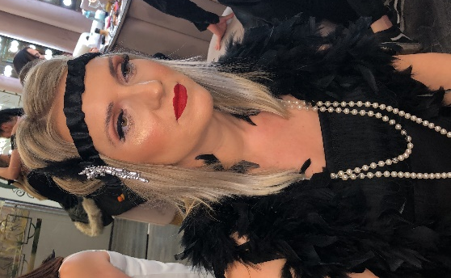
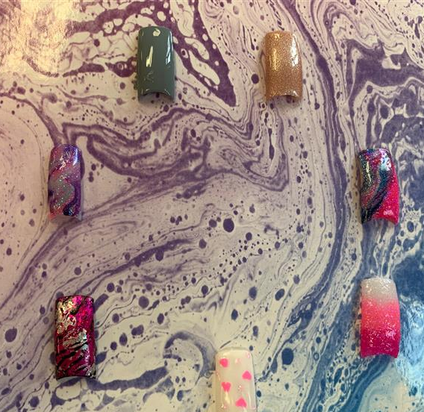

This transition pack is designed to help you make the change from year 11 to college, introducing a new way of working and to help you make the most of the opportunities which you will be given.

Here are some tasks to complete over the holiday ready for an assessment in September. The pack will also help you to look at the skills which you will need for a working environment. You do need to work your way through the transition tasks in the pack over the summer and hand in to your tutor when you start in September.

You will use this written work as evidence in your portfolio. We will show you how to reference this work at the beginning of the term. The work is set to help you to understand the importance of Equality and Diversity and how to behave in a manner that enables children to develop as confident, self-assured individuals. This unit of work underpins everything we do in our work settings and will help you to develop inclusive practice.

NB: All this work will be used as part of your course work so please give it the time and effort deserving of the qualification. This work will also help us determine if you show the academic ability required to complete the course to the standard set by the awarding body
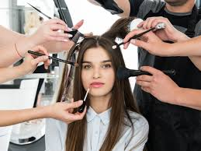
Personal behaviour in the salon environment
Your behaviour is expected to be of such standard that it reflects well on the client and your colleagues, as well as yourself.

Think about what could happen if you pranced about the salon in a light hearted way acting as though you were trying to make people laugh. You could cause an accident!

Make a list of how you think you should behave within the salon

..........................................................................................................................................

..........................................................................................................................................

............................................................................................................................................

............................................................................................................................................

………………………………………………………………………………………………………

Health and safety responsibilities

Complete the following table by describing how your job role within the salon meets each of the following legislation requirements for health and safety.

Legislation | Example of employee’s responsibilities

Health & Safety at Work Act

The Workplace (Health, Safety & Welfare) Regulations

The Provision and use of Work Equipment Regulations

The Manual Handling Operations Regulations

The Personal Protective Equipment at Work Regulations (PPE)
The Control of Substances Hazardous to Health Regulations (COSHH)
The Electricity at Work Regulations

The Health and Safety (Display Screen Equipment) Regulations

The Health and Safety and First Aid Regulations and the reporting of accidents

Skin types
What skin type am I?

- I am shiny in appearance.
- I have large pores (ostiums).
- I can be coarse and thick in texture.
- I can suffer from blockages and then get comedones, papules or pustules.
- I age well. though.

What skin type am I?

______________________
- I am usually flaky, and tight.
- I age quickly.
- I have dilated capillaries that give me a ruddy appearance.
- I am usually quite sensitive.
- I am usually quite fine in appearance.
- I am affected by changes in temperature and extremes, use of soaps or harsh products.
- I also don’t produce a lot of sebum.

What skin type am I?______________

________________________

- I have even pore sizes.
- I am very rare.
- I have even oil and moisture balance.
- I am born this way.

What skin type am I?

____________________
- I am a mixture of two skin types.
- I have certain areas that are oily and others that are dry.
- I need specific products to manage both areas.

What skin type am I?

_____________________

Contra indications

State the reasons why the treatment must not be carried out on a client suffering from the following contra-indications.

Contra indications | State the reasons why treatment must not be carried out
Eczema

Cuts and abrasions

Broken Bones

Diabetes

Infectious skin conditions

Respiratory conditions

Impetigo

Cleaning tools and equipment

Fill in the most suitable method of cleaning and/or sterilising tools and equipment for styling and dressing hair.

Tools and equipment | Suitable methods of cleaning and sterilising

Brushes

Combs

Rollers

Straighteners

Hand held hairdryers

Hood dryers

Hair Growth Cycle
Draw the different stages of the hair growth cycle to fit the description in the boxes below. Add the text to explain the different stages.
- Anagen | - Catagen | - Telogen
Diagram | Diagram | Diagram
Explanation of the anagen stage. | Explanation of the catagen stage. | Explanation of the telogen stage.

