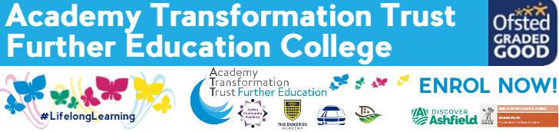

Childcare & Education:
SUMMER TRANSITION BOOKLET

What is childcare & education?
High quality childcare, play opportunities and early education are crucial for young children to get the best possible start in life and working with children can be an incredibly rewarding experience.
If you love being with children, are dedicated to keeping them safe and happy, and are interested in educating and stimulating them to prepare for later life then a career in childcare could be perfect for you.
Childcare professionals play a vital role in supporting, inspiring and laying the foundation for all-round development in children’s formative years and preparing them for adulthood. The work of childcare professionals has a far reaching impact. Recognising the importance of play in supporting children’s social and emotional development and creativity, childcare professionals enable children to be resilient and prepare them for the range of transitions in their lives.

All kinds of people work in early years and childcare. Children need a variety of positive role models and good influences. School leavers and students, adults of all ages, people from all cultures and backgrounds, men and women - with or without previous experience - all play an important part.

They share common qualities such as patience, enthusiasm, empathy, a sense of responsibility and a sense of fun!
Working with children often involves working with parents too, helping them to understand and support their child's development in the home learning environment. It also often involves working with others or as part of a team.

When you begin the course in September you will spend 3 days in college and 2 days in your work placement each week. The work placements are arranged, after discussion with each learner and course staff. Your work placement is a mandatory part of your course and commitment and attendance to placement is very important as without it you cannot remain on the course or complete the qualification.

This transition pack is designed to help you make the change from year 11 to college, introducing a new way of working and to help you make the most of the opportunities which you will be given.

Here are some tasks to complete over the holiday ready for an assessment in September. The pack will also help you to look at the skills which you will need for a working environment. You do need to work your way through the transition tasks in the pack over the summer and hand in to your tutor when you start in September.

You will use this written work as evidence in your portfolio. We will show you how to reference this work at the beginning of the term. The work is set to help you to understand the importance of Equality and Diversity and how to behave in a manner that enables children to develop as confident, self-assured individuals. This unit of work underpins everything we do in our work settings and will help you to develop inclusive practice.

NB: All this work will be used as part of your course work so please give it the time and effort deserving of the qualification. This work will also help us determine if you show the academic ability required to complete the course to the standard set by the awarding body

Transition Tasks:
Task 1 (level 3 task only)
The Early Years Foundation Stage framework is the legislation and guidance for the learning and development of children up to 5 years old (end of reception class). Knowledge and understanding of the early years will form a large part of both academic and practical aspects of your course.
Research the EYFS and read about the 4 principles which support practice within the EYFS framework.
These are
- Unique Child
- Positive relationships
- Enabling environments
- Learning and development

For each principle write an explanation of what is covered within that area and how an early years practitioner can support children using information about that principle. Then look at the early learning goals:
- Identify the Prime areas of learning (3) with an explanation of what each area covers.
- Identify the Specific areas of learning (4) with an explanation of what each area covers.

Task 2
You need to research using books or the internet to find some information for this piece of work. Do reference where you have found out your information at the end of the work.
Identify settings which provide early years education and care.
Create a poster with details of the different types of settings that provide early years education and care. You should include a minimum of five (5) different types of early years provision.

Task 3
Discuss duties and responsibilities of the early years practitioner
Write in detail about the expected responsibilities and the limits and boundaries (things you can do and things you cannot) of the practitioner’s role in the early years setting. Identify two (2) areas of the role that will require you to seek advice and guidance from other members of staff.

Task 4
Produce a factsheet that explains the following key terms and include examples: Equality, Inclusion, Diversity and Discrimination

Task 5
Produce a table, booklet or timeline of information that explains development patterns of children from birth to 19 years old. You can see lots of colourful examples on Pinterest (follow this link). This piece of work can be used from level 1 to level 3 so it is important to put in a lot of effort!
https://www.pinterest.co.uk/pin/231724343312956286/
Remember you need to show development from birth to 19 years for the following areas of development:
Physical
Intellectual (cognitive)
Language
Emotional (including moral and behaviour)
Social

TASK 6
What are your own Childcare and Education career aspirations?
Explain them below and then outline what you think you still need to do in order to go on and achieve them…

